**CDA3201L Lab #3**

**Ring Oscillator with 3 NAND**

Hanz Chua U26738740

Viraj Amarasinghe U14806439

Jian Gong U42910460

**Introduction**

In this lab, we are assembling a NAND-gate-based ring oscillator circuit and using an oscilloscope to measure the period, computed frequency, and measured frequency.

**Methods and Materials**

* Breadboard
* Wires
* 7400LS00 Quad NAND Gate IC
* Oscilloscope
* Wave Generator
* Power Supply
* Wires

1. First, we assemble our oscillator circuit. We take our NAND gate and place it on the bridge of the breadboard. We first connect vcc (pin 14) and ground (pin 7) to the + and – lines of the breadboard. We then designate an input, in this case it would be pin 1 of our NAND gate IC. Pin 2, will be the output of the last NAND gate. We connect pin 3, which is our first NAND gate’s output and connect it to the next NAND gate inputs, which in our case would be pin 13 and pin 12. From there we connect the seconds NAND gate’s output to the last NAND gate’s inputs, which in our case is pin 4 and 5. We finally connect pin 6, the output of the last NAND gate, and connect it to pin 2, which is the second input of the first NAND gate. The oscillator circuit is now complete.
2. We then connect the power supply to the circuit, but attaching wires to the + and – lines of the breadboard.
3. Connect the black wire of the wave generator to the ground of the breadboard and the red wire of the wave generator to the input of the circuit, or pin 1.
4. We take our oscilloscope and connect the ground to the ground of the breadboard and connect the red to the output of our breadboard.

**Result**

We observed oscillations when the input was 1 and flat lines when input was 0. Because we took the liberty of connecting a secondary oscilloscope to observer the input, we noticed he propagation delay in between each cycle in the circuit. The results came out as expected and contributed to the goal of the lab; to visualize and emphasize the significance and effects of delay in a circuit

**Conclusion**

In conclusion, we assembled the oscillator circuit, connected it to power, wave generator, and oscilloscope. We were able to observe the delays in between the oscillator circuit’s cycles. Problems we encountered included unreadable graphs, since our oscillators had various settings that have been left from its previous users. Some computers couldn’t read our oscilloscopes so we would have to switch computers.

**Assignment Questions**

1. 100.4 ns
2. 100 ns
3. 10 MHz

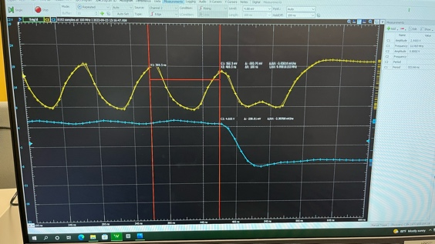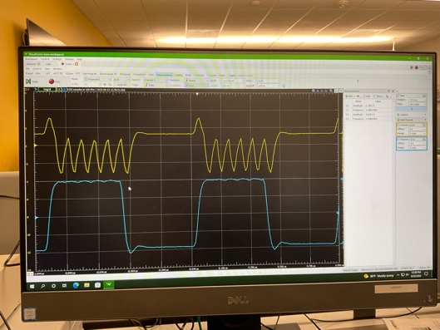4.

5. i. 15 ns

ii. 15*3 = 45 ns

iii. Assuming z = 0, when en = 1, the input goes thru the gates, which always flips the input, As long as en = 1. This is because when en = 0, the only output nand can give is 1 no matter how many times we invert it, but when en = 1, it can either output 1 or 0.

iv. 2*gates*gate delay